Testimony of Robert Roach, Jr.
General Secretary-Treasurer
International Association of Machinists
and Aerospace Workers

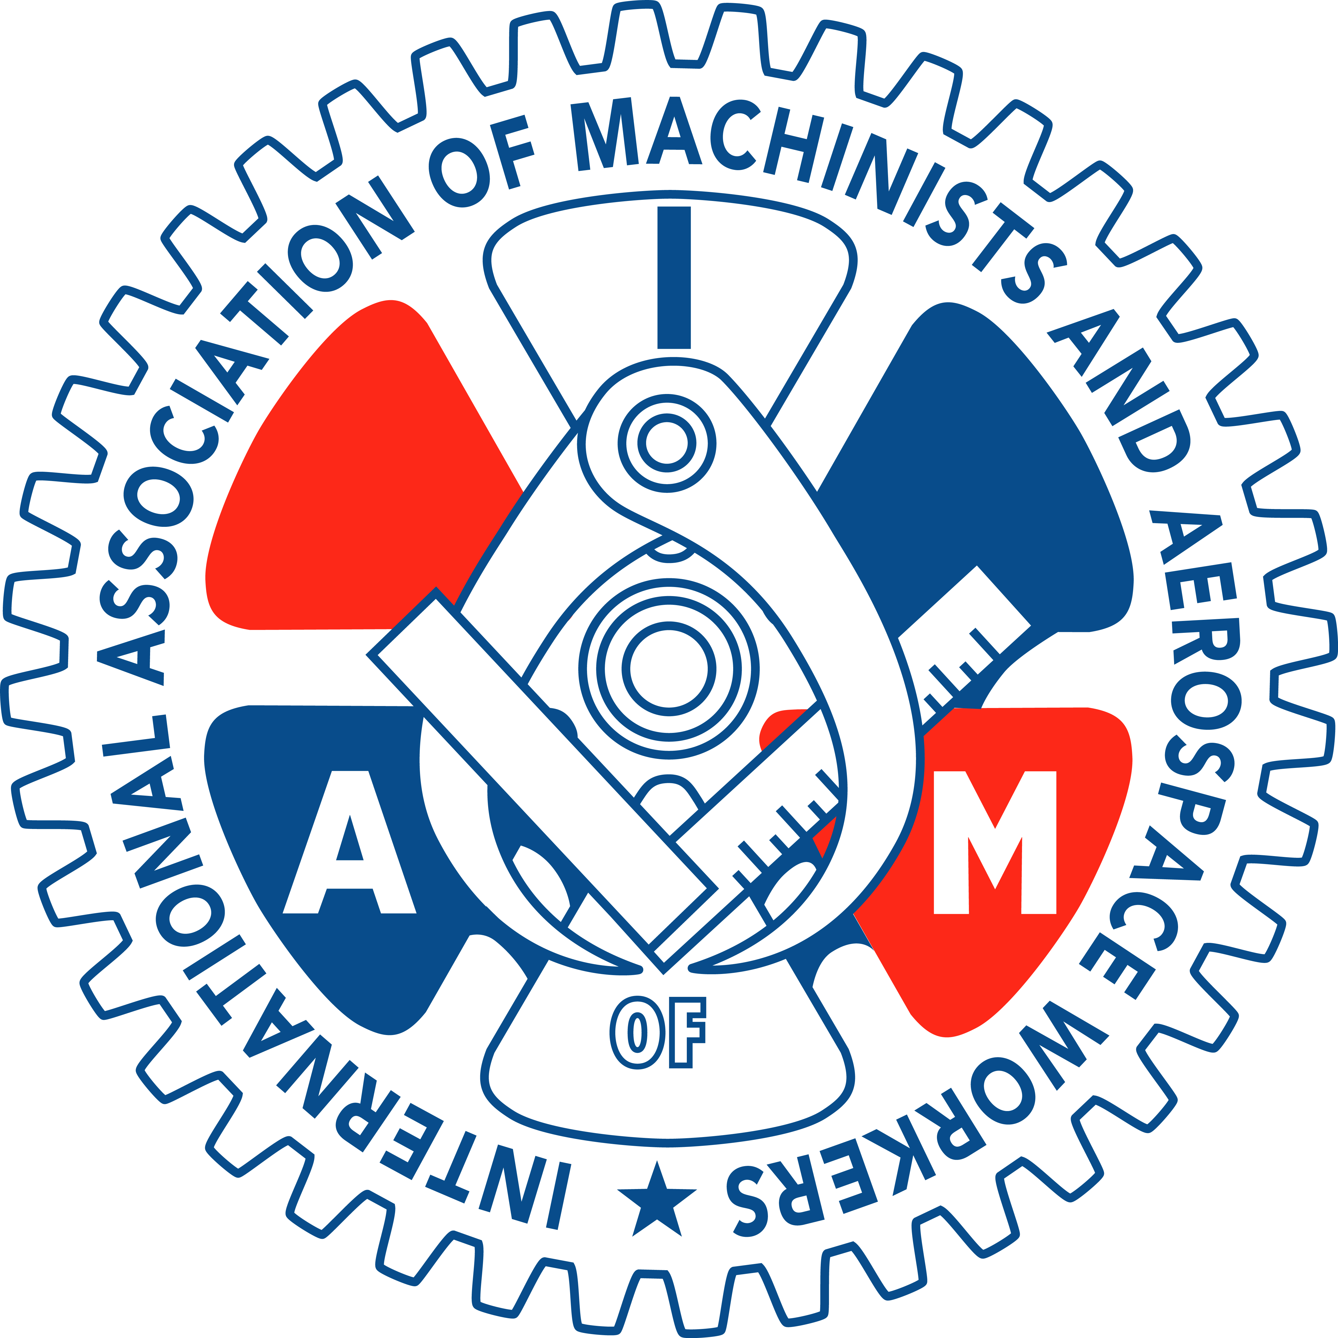

Field Hearing of the ABI Commission to Study the Reform of Chapter 11

March 14, 2013
Testimony of

Robert Roach, Jr.
General Secretary-Treasurer
International Association of Machinists and Aerospace Workers

at the Field Hearing of the
American Bankruptcy Institute
Commission to Study the Reform of Chapter 11

May 14, 2013

Thank you, Chairman and members of this Commission for the opportunity to speak to you today and to address the issue of Chapter 11 reform from the workers’ perspective. I am General Secretary-Treasurer of the International Association of Machinists and Aerospace Workers (IAM). I also currently serve as Co-Chair of the IAM National Pension Fund which has over $9 billion in assets and Co-Chair of the IAM Health and Benefit Trust Fund. The IAM is among the nation’s largest industrial trade unions, representing nearly 700,000 active and retired members under more than 5,000 contracts in transportation, aerospace, shipbuilding, manufacturing and defense-related industries.

The position of IAM General Secretary-Treasurer is the Union’s second highest office, but I have not always held such a high position with the Union. I began my career working as a ramp serviceman for Trans World Airlines (TWA) in 1975 and gradually worked my way up the union ladder representing my fellow airline employees in contract negotiations, administration and enforcement. In 1999, I became IAM General Vice President for Transportation. My career as an airline employee and union representative thus coincides in time with the experience of workers under the Bankruptcy Code adopted by Congress in the Bankruptcy Reform Act of 1978.
I have personally experienced the bankruptcy process both as an employee of TWA which filed for Chapter 11 three separate times, and as a union official representing workers in the manufacturing and transportation industries whose livelihoods were at stake in the numerous bankruptcies that have ravaged those sectors of our economy over the past several decades. As a retired employee of TWA and then beginning in 2001 American Airlines, I currently receive a pension of $326 per month from the PBGC for the 36 years that I worked for the airline. Even when combined with railroad retirement or social security, that pension is not nearly enough to live on. Fortunately for me, I have another pension from my union position, but that is simply not the case for the tens of thousands of retired airline employees whose pensions were decimated in airline bankruptcies.
Thus, I speak to you today as both a union representative with extensive bankruptcy experience and as a retired airline employee who has personally felt the effects of airline bankruptcies. I have witnessed the destruction of tens of thousands of lives through the chapter 11 process. For those reasons, the IAM membership strongly supports modifications to sections 1113, 1114 and the current pension laws to better protect employees in business bankruptcies.
While business failure is an inevitable part of the capitalist system, it disproportionally and inequitably impacts workers. The process of “creative destruction” is often simply destructive for workers, with nothing creative about it. When companies fail, workers lose their jobs, their incomes, their health insurance, their pensions, and their retirement accounts, among other things.
Bankruptcy law needs to do more to protect the interests of these most vulnerable economic stakeholders. In the recent years, however, just the opposite has occurred.
While chapter 11 bankruptcy can provide struggling companies an opportunity to re-group and avoid liquidation, it is increasingly abused as a means to get a leg-up on the competition by placing an undue burden on employees and retirees. The IAM has an enormous interest in seeing a floundering company survive because, simply put, if the company doesn’t survive neither do our members’ jobs. But companies are increasingly using bankruptcy as a means to take what they can from employees outside of the normal collective bargaining process, not just what is needed for a corporation to survive.

In 1984, Congress created section 1113 of the bankruptcy code in response to companies using bankruptcy as a weapon to eliminate employee collective bargaining agreements altogether. Frank Lorenzo famously manipulated the system in just such a way. During the past decade, similar abuse of the bankruptcy process has re-appeared, ironically in the air transportation industry from which Lorenzo was barred, as well as in other industries.

Under current bankruptcy law, if a company seeks to modify labor agreements and a union does not comply, the company can ask a judge to reject their contracts, and employees have little or no recourse. Under this unfair corporate advantage, employees have suffered greatly, and changes are needed.

Section 1113 of the current law has crippled the collective bargaining process, not enhanced it. It does not offer the employee protections Congress envisioned in 1984. Section 1113 only provides a checklist of perfunctory steps that must be followed before a judge can reject a labor contract. It does little to encourage good-faith bargaining.

In fact, recent court decisions actually incentivize employers not to reach agreement with their unions. Some courts have held that in airline bankruptcies whose labor relations are governed by the Railway Labor Act (RLA), workers do not have the right to engage in self-help if the bankruptcy court rejects their collective bargaining agreement.

Good-faith bargaining can only be achieved when there is a level playing field and both parties have something to gain – or lose – at the bargain table. Today, there is no downside for airlines failing to reach agreement with their unions. The airlines simply follow section 1113 as a roadmap that ends either in contract rejection or employees accepting a disproportionate share of the bankruptcy pain. The right to self-help ensures that both bargaining parties understand the consequences of failing to reach a negotiated agreement, and that right must be guaranteed for all employees.

The current, inequitable bargaining process has had dramatic consequences in the airline industry.

Immediately after its chapter 11 filing, United Airlines asked a bankruptcy judge to impose 14% “emergency” pay cuts on IAM members. The judge complied. More long-term cuts in pay and benefits cost IAM members $460 million a year (or $2.644 billion over the life of the agreement). United then took steps to cut health benefits for existing retirees and filed a motion in court to ask a judge to impose cuts if agreements could not be reached with the retirees' representatives. This merciless move cost fixed-income retirees $50 million a year.

In the summer of 2004, United unilaterally ceased funding its pension plans, the first in a series of steps which ultimately led to the termination of all United pension plans by the Pension Benefit Guaranty Corporation (PBGC).

In January 2005, United once again sought and received “emergency” pay cuts from the bankruptcy court - this time it was an additional 11% on top of the previous 14% emergency cuts. Six months later, IAM members gave up another $176 million a year to save United. Savings attributable to the termination of IAM member’s pensions saved United an additional $217 million a year.

In total, IAM members were forced to sacrifice more than $4.6 billion for United Airlines to survive.

In US Airways’ first bankruptcy in 2002, IAM members agreed to two rounds of contract concessions totaling $276 million per year, or $1.8 billion over 6 1/2 years. Workers’ pay was cut by an average of 7.5%. Employees also experienced drastic increases in their contributions for healthcare coverage, which had the effect of reducing take-home pay even further.

Immediately after filing for bankruptcy for the second time in as many years, US Airways management petitioned the court to impose “emergency” pay cuts of 23% for all union-represented employees. The bankruptcy court reduced the amount to a still-staggering 21% cut in pay. Eventually, US Airways’ mechanics saw their pay cut by an average of 15%. Management and salaried employees' pay, however, was reduced by only 5% to 10%.

IAM members at Northwest Airlines saw their pension plans frozen, and took 11.5% pay cuts as a result of management’s bankruptcy. This story has been repeated throughout the airline industry.

And how did the executives who steered their airlines into bankruptcy fare in the process? They were rewarded for failure.

US Airways CEO David Siegel received $1.45 million the year his airline exited its first bankruptcy, and another $9 million in 2003, the year in between the airline’s two bankruptcies. Siegel’s successor, Bruce Lakefield, orchestrated massive pay, benefit and job cuts for front-line employees during the airline’s second bankruptcy - but he refused to accept a wage cut for himself.

Northwest CEO Doug Steenland was granted $26.6 million in stock upon the carrier’s 2007 exit from bankruptcy, plus a salary that year of over $500,000.
In 2006, on the day after emerging from the longest bankruptcy in airline history, United Airlines CEO Glenn Tilton was rewarded with $20 million in stock and options. During the first month out of bankruptcy, he was granted additional stock and options valued at $18 million. Tilton also had a base salary of $687,000 and bonuses totaling $839,000 that year. Finally, he had $210,000 worth of "other compensation" including a car & driver and reimbursement of taxes. Tilton’s total compensation in the first year after United’s bankruptcy was $39.7 million.
In these major airline bankruptcies, much of the financial sacrifices employees made to save their company were diverted into the pockets of the people responsible for the company’s failure. It shouldn’t be surprising that since these bankruptcy cases focused more on what could be extracted from employees than on developing new and sustainable business plans, the airlines struggled after exiting bankruptcy and have since looked for mergers to save them.

Because airlines such as American, Delta, United, Northwest, US Airways and others successfully manipulated the bankruptcy process to extract billions from employees in the form of contract modifications, other non-bankrupt carriers threaten employees with bankruptcy if they too do not accept contract concessions. Bankruptcy is threatened not to avoid liquidation, but to lower labor costs to remain competitive in the industry’s race to the bottom. The current bankruptcy laws are thus used not because of a legitimate need to restructure or as an alternative to liquidation, but as a bargaining cudgel against employees.

While airline employees have been hard-hit by bankruptcy, they are certainly not alone. Auto, steel, banking, newspaper, cable television, and trucking companies are among the more than 100 publicly-traded companies that seek chapter 11 bankruptcy protection each year.

IAM members at auto parts supplier Dana Corporation saw their company eliminate retiree medical benefits in bankruptcy. Other IAM members at Kaiser Aluminum felt the stinging effects of bankruptcy when the PBGC took over administration of their terminated company-sponsored defined benefit pension plan. Current and future retirees lost value in their promised benefits as well as supplemental disability benefits the PBGC does not guarantee. Such disability and early retirement benefits, while not critical for white-collar workers, are often a lifeline for manual workers in heavy industry.

Bankruptcy law should be amended to ensure that employers engage in truly good-faith bargaining when seeking contract modifications. Companies should no longer be able to use the bankruptcy code to eliminate decades of collective bargaining gains when there is no justifiable reason - other than corporate greed. There are some instances where truly good faith bargaining has produced acceptable results, but those instances are the exception, rather than the rule.

In the recent Hawker Beechcraft bankruptcy, the IAM opposed the debtors’ efforts to terminate its members’ pension plan, ultimately negotiating a consensual, ratified revised collective bargain agreement with a frozen defined benefit pension plan, even though the debtors other two non-union defined benefit plans were terminated. Earlier in the case, the IAM defeated the debtors’ motion for a key employee incentive plan for senior executives that was supported by the senior secured creditors, the DIP agent, and the creditor’s committee. When a global settlement was later advanced that would support confirmation of a plan that kept both the union employee pension plan and a management incentive program, however, it suddenly found lender and creditor support.

If employees are called upon to sacrifice in order to resurrect their bankrupt employer, bankruptcy law must require that everyone from the break room to the board room shares the pain. Executive bonuses, stock grants, and other compensation enhancements proposed during a bankruptcy that replace those in effect prior to the commencement of the case should be prohibited. Any incentives proposed for insiders and senior executives should be strictly limited to only those found to be essential for the survival of the business or its orderly liquidation. Bonuses paid to executives after emerging from bankruptcy should be reviewed by the court and take into account the amount of pain inflicted upon employees during and following bankruptcy. Employees must not be asked to sacrifice wages, pensions, healthcare and jobs in order to line the pockets of the same people who bankrupted the company in the first place.

In Hostess, the bankruptcy court granted section 1113 relief against IAM represented employees despite the fact that the IAM represented employees made counter proposals that met the economic ask of the debtors, because the debtors refused to accept any counter proposal that would allow the IAM represented employees to keep a defined benefit pension through the IAM National Pension Plan, a multi-billion dollar multiemployer pension plan.

Defined benefit plans are particularly important for hourly wage workers who have no cushion in their retirement savings plans to withstand the risks and vagaries of the financial markets. Defined contribution plans, on the other hand, suffer the risks of both the market and also outliving the savings. Both of those factors make it extremely difficult for our members to feel comfortable that there is in fact a tangible benefit in a defined contribution plan.

It was beyond ironic to the IAM members at Hostess that they were being forced to give up their defined benefit pensions because their employer which had ceased making pension contributions argued in bankruptcy court that the potential withdrawal liability from a multiemployer pension plan such as the IAM National Pension Fund, an over-funded green plan which has not had any withdrawal liability since its inception in the mid-1980s, except perhaps for a brief period in the fall of 2008, was a credit risk. That is an absurd result given Hostess’ abysmal credit worthiness.

The IAM believes that companies should be required to pay into pension funds as benefits are earned. Employees accept lower immediate wages based on an employers’ promise of a pension. Employers should not be allowed to use those funds at their whim and then abuse bankruptcy laws to break the pension promises workers count on to live in retirement with dignity. Additionally, the PBGC should be given the financial resources to guarantee all of the vested benefits promised in a pension plan without reduction or maximums.

In Hostess, the debtors paid some post petition administrative expense claims, but unilaterally chose not to pay millions of dollars in post petition multiemployer defined benefit contributions, while continuing to accrue those contributions. The pension troubles in the airline and steel industries were caused by employers taking advantage of loose pension funding requirements and using equity in pension plans to defer actual cash contributions on behalf of employees. When the stock market tanked, so did the pension plans. Pension defaults in the steel, airline and other industries helped the PBGC move from a surplus of $7.7 billion at the end of fiscal year 2001 to a deficit of $34 billion today.

Currently, the PBGC has no power in bankruptcy to force companies to make required pension contributions. A company can simply refuse to pay and force the PBGC to initiate a pension termination to prevent a plan from accruing further pension liabilities. Congress must make bankruptcy a less attractive mechanism to dump pension obligations on the PBGC. The PBGC also needs to have the ability to enforce pension funding rules on a level basis – whether or not a plan sponsor is in bankruptcy.

Comprehensive bankruptcy reform should also increase the priority claim limits for wages, provide employees and retirees with the ability to recover pension losses, and direct judges to consider how reorganization plans will impact jobs, collective bargain agreements, pensions and retiree benefits when approving plans.

The IAM strongly supports comprehensive bankruptcy reform that will protect our nation’s workers and require shared sacrifice among all stakeholders.
Thank you again for the invitation. I look forward to your questions.

