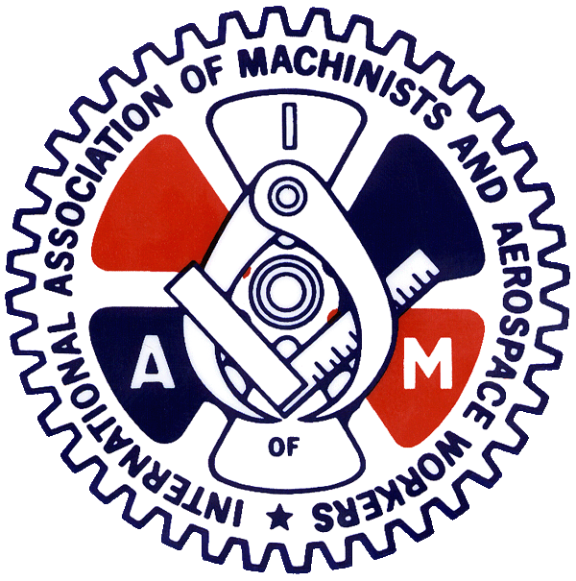
International Association of Machinists
& Aerospace Workers

PRESERVE RETIREMENT SECURITY
Co-sponsor the Keep Our Pension Promises Act (KOPPA)

Historically, pensions have constituted a critical component of a sustainable retirement. Yet, in the closing moments of the 113th Congress and without debate or public hearings, legislation was passed that lets the trustees of “deeply troubled” multiemployer plans slash retirement benefits for existing retirees to as low as 110 percent of the Pension Benefit Guarantee Corporation’s (PBGC) maximum payment.

This unprecedented attack on the living standards of retirees undermines the basic premise of the Employee Retirement Income Security Act (ERISA)—that once you retire your pension will not be cut. ERISA’s “anti-cutback rule” prevents reductions in benefits being paid to retirees and their surviving spouses because the overwhelming majority of retirees do not have the means to replace the lost income. Allowing cuts in promised benefits is a ticket to poverty.

The IAM strongly opposes these changes to ERISA’s anti-cutback rule and supports legislation, the Keep Our Pension Promises Act (KOPPA), introduced by Senator Sanders and Representative Kaptur to restore ERISA’s anti-cutback rule. The legislation would also:

Strengthen multi-employer pension plans
This bill allows plans to partition off “orphaned” participants into a separate plan, giving participating employers relief from having to shoulder the full financial burden and risk of underfunded “orphaned” participants. This will help ensure that plans can become financially secure and strong.

Provide additional funding to help protect retirees and the PBGC
A legacy fund would be created within the Pension Benefit Guaranty Corporation (PBGC) to help ensure that participants in partitioned plans will continue to receive the benefits they depend upon. The cost to shore up the PBGC and create this legacy fund would be covered by closing tax loopholes used by the very wealthy to accumulate expensive artwork and hundreds of millions of dollars in tax-advantaged savings.

Protect employers participating in multi-employer plans
This bill ensures pension obligations are prioritized during bankruptcies. This helps the remaining employers by making it less likely they become responsible for underfunded plans.

We in the Machinists Union have experienced firsthand the benefits of a well-run multiemployer pension plan. The IAM National Pension Fund has more than 1,650 contribution employers and is the fifth largest multiemployer plan in the U.S. With assets exceeding $10.7 billion, the Fund provides retirement security to over 90,000 retirees and beneficiaries. .

