IAMAW WORKERS’ MEMORIAL

You or your lodge can be a part of the Workers’ Memorial by purchasing a 4 x 8 personalized brick. You may order a brick with 2 lines of lettering with up to 20 characters per line (including spaces on each line) without the logo for $100.00. You could also purchase a brick with 3 lines of lettering with up to 15 characters per line, along with the IAM logo for $125.00.

OR

If you wish to purchase a larger brick, an 8x8 can be purchased for $200.00. You may order this brick with 4 lines of lettering with up to 20 characters per line without a logo, or with 2 lines of lettering with up to 15 characters per line, along with your own preferred logo or the IAM logo.

The lighthouse is located at the William W. Winpisinger Education
and Technical Center. The memorial bricks surround the lighthouse.

Reserve your own piece of history today!

Lettering for the 4x8 brick should be as follows:

__ __ __ __ __ __ __ __ __ __ __ __ __ __ __ __ __ __ __ __

__ __ __ __ __ __ __ __ __ __ __ __ __ __ __ __ __ __ __ __

__ __ __ __ __ __ __ __ __ __ __ __ __ __ __ __ __ __ __ __ (IAM Logo only)
(Only use 15 characters if you plan to include the IAM logo)
(You must count spaces between words)

Name: _______________________ Home Phone No.: (____) _____________

Address: ________________________________________________________

Make checks payable to: IAM CREST Workers’ Memorial Fund. Reserve your brick today by
returning this form and check to:
Safety and Health Department
9000 Machinists Place
Upper Marlboro, MD 20772

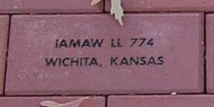

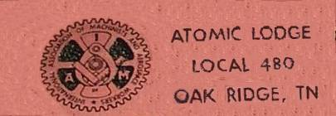

Lettering on the 8x8 brick should be as follows:

__ __ __ __ __ __ __ __ __ __ __ __ __ __ __ __ __ __ __ __

__ __ __ __ __ __ __ __ __ __ __ __ __ __ __ __ __ __ __ __

__ __ __ __ __ __ __ __ __ __ __ __ __ __ __ __ __ __ __ __ (No logo)

__ __ __ __ __ __ __ __ __ __ __ __ __ __ __ __ __ __ __ __ (No logo)
(You must count spaces between words)

Name: _______________________ Home Phone No.: (____) _____________ Logo Attached

Address: ________________________________________________________

Make checks payable to: IAM CREST Workers’ Memorial Fund. Reserve your brick today by
returning this form and check to:
Safety and Health Department
9000 Machinists Place
Upper Marlboro, MD 20772

