IAMAW Workers’ Memorial at the William W. Winpisinger Education & Technology Center
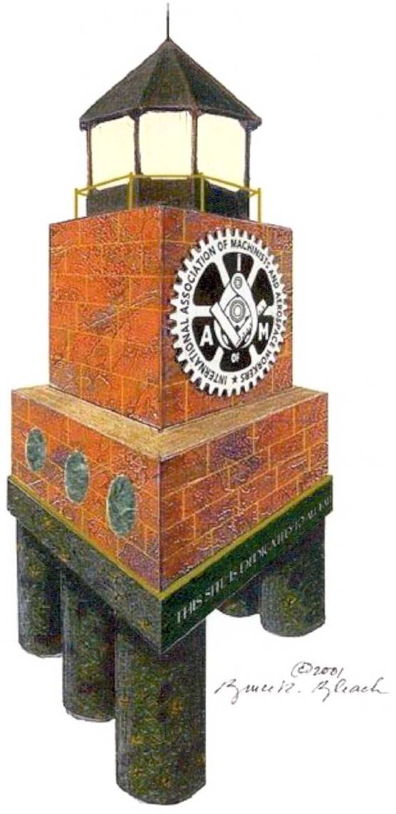

The names of IAM members who have died on the job will be memorialized with their name, local lodge and date of death. This is done at no cost to the local lodge. Please provide this information for all members of your local who have lost their lives as a result of occupational injuries or illnesses. Return this form to the IAM Safety and Health department, 9000 Machinists Place, Upper Marlboro, MD 20772.

Name:

Local Lodge:

Date of Death:

Cause of Death:

Duplicate this form for additional members

