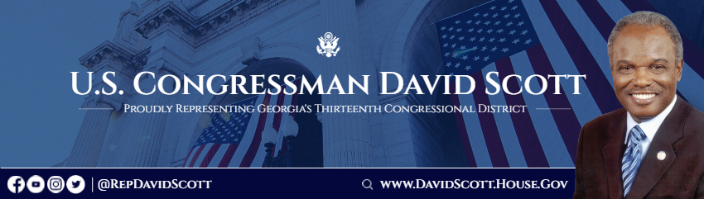

FOR IMMEDIATE RELEASE: February 27, 2024
Media Contact
Catherine Harney, davidscott.press@mail.house.gov

Congressman David Scott’s Statement on Delta Employees’ Unionizing Efforts

WASHINGTON— “As a longtime fighter for unions, I stand alongside the Delta flight attendants, fleet service workers, and technicians fighting to organize and join a union. The pathway to ensure workers remain free to join the union of their choice must exist without fear of reprisal or interference. Delta has a long history of employing unionized workgroups across its operations and fostering an inclusive workplace culture, and I look forward to working with all sides to protect workers' freedom to make their own decisions.”


  

