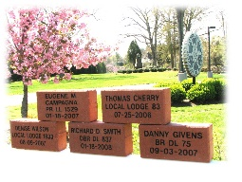
IAM WORKERS’ MEMORIAL BRICKS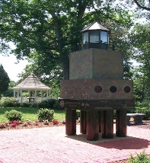

Honor your local or fallen brothers/sisters and be a part of the Workers’ Memorial by buying personalized bricks to be placed at the lighthouse located at the William W. Winpisinger Education and Technology Center. Memorial bricks surround the lighthouse as well as the pathway to the gazebo. New in 2022, you can add a 4x4 Black Granite replica tile with the purchase of a brick for an added $10.00 each.

Brick and tile orders take 4-6 weeks for processing and delivery so all orders must be received no later than March 1st for delivery and installation prior to the ceremony in April.

Sizes and pricing:

Brick Size | Text Only | Text w/ IAM Gear | Text w/ Custom Logo | Pricing | 4x4 Replica Granite Tile  
4x8 | Maximum 3 lines 20 spaces per line (including spaces)  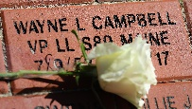 | Maximum 3 lines 15 spaces per line (including spaces)  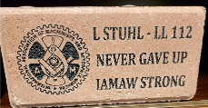 | Maximum 3 lines 15 spaces per line (including spaces) | Text Only $100.00  Text w/ IAM Gear $125.00  Text w/ Custom Logo $150.00 | + $10.00 per brick order
8x8 | Maximum 6 lines 20 spaces per line (including spaces)  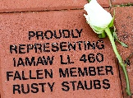 | Maximum 5 lines 20 spaces per line (including spaces)  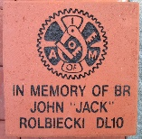 | Maximum 5 lines 20 spaces per line (including spaces)  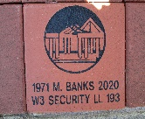 | Text Only $200.00  Text w/ IAM Gear $225.00  Text w/ custom logo $250.00 | + $10.00 per brick order
4x8 | Maximum 3 lines  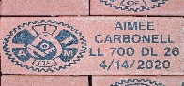 | Name  Lodge  Date of Death | n/a | No charge for members who have died on the job as a result of injury or illness | $10.00 per brick order

Complete the proper form and return with check payable to “IAM CREST Worker’s Memorial Fund” to:
IAM Safety and Health Department
9000 Machinists Place, Room 204
Upper Marlboro, Maryland 20772

